***Dermatology clinic app Requirements wqwSpecification***

**Food Delivery System Requirements Specification**

**Group members:**

[David Keçi](mailto:dkeci21@epoka.edu.al)

[Greisi Jaho](mailto:gjaho21@epoka.edu.al)

Era Mulla [Erisa Zaimi](mailto:ezaimi21@epoka.edu.al)

Ardisa Beqja

Klea Haxhiu

Page **1** of **126**

***Dermatology clinic app Requirements Specification***

**Table of Contents**

**1.Executive Summary** ............................................................................................................................. **3** 1.1 Project overview............................................................................................................................ 3 1.2 Purpose and scope of this specification .......................................................................................... 4 **2.Product/ Service Description** ............................................................................................................... **5** 2.1 Product context ............................................................................................................................. 5 2.2 User Characteristics........................................................................................................................ 5 2.3 Assumptions…………………………………………………………………………………………………………………………………..7

2.4 Constraints …………………………………………………………………………………………………………………………………….8 2.5 Dependencies…………………………………………………………………………………………………………………………………8 **3.Requirements**………………………………………………………………………………………………………………………………………9 3.1 Functional Requirements ……………………………………………………………………………………………………………...9

3.2 Non-Functional Requirements………………………………………………………………………………………………………18 3.2.1 Product Requirements………………………………………………………………………………………………………………18 3.2.1.1 User Interface Requirements………………………………………………………………………………………………….18 3.2.1.2 Usability………………………………………………………………………………………………………………………………….20 3.2.1.3 Efficiency………………………………………………………………………………………………………………………………..20 3.2.1.3.1 Performance Requirements…………………………………………………………………………………………………21 3.1.2.3.2 Responsiveness……………………………………………………………………………………………………………………21 3.2.1.4 Dependability ……………………………………………………………………………………………………………………….21

3.2.1.5 Security………………………………………………………………………………………………………………………………..22 3.2.2 Organizational Requirements………………………………………………………………………………………………….22 3.2.1.1 Environmental Requirements………………………………………………………………………………………………22 3.2.1.2 Operational Requirements ………………………………………………………………………………………………….22 3.2.1.3 Development Requirements…………………………………………………………………………………………………23 3.2.3 External Requirements…………………………………………………………………………………………………………….23

Page **2** of **126**

***Dermatology clinic app Requirements Specification***

3.2.3.1 Regulatory Requirements…………………………………………………………………………………………………….23 3.2.3.2 Ethical Requirements…………………………………………………………………………………………………………..24 3.2.3.3 Legislative Requirements…………………………………………………………………………………………………….24 3.2.3.3.1 Accounting Requirements…………………………………………………………………………………………………25 3.2.3.3.2 Security Requirements…………………………………………………………………………………………………….25

3.3 Domain Requirements……………………………………………………………………………………………………………..25 **4.Software Design**…………………………………………………………………………………………………………………………….26 4.1 User Scenarios…………………………………………………………………………………………………………………………….26 4.2 Use Cases …………………………………………………………………………………………………………………………………..32 4.3 Use Cases Extended …………………………………………………………………………………………………………………….37

4.4 BPMN…………………………………………………………………………………………………………………………………………..54 4.5 Data Flow Diagrams……………………………………………………………………………………………………………………..58 4.6 Entity-Relationship Diagram………………………………………………………………………………………………………61-62 4.7 Activity Diagrams…………………………………………………………………………………………………………………………63 4.8 Timing Diagram……………………………………………………………………………………………………………………………80 4.9 State Diagram……………………………………………………………………………………………………………………………...80 4.10 Sequence Diagrams…………………………………………………………………………………………………………………… 84 4.11 Collaboration Diagrams……………………………………………………………………………………………………………..89 4.12 Class Diagram…………………………………………………………………………………………………………………………….94 4.13 Object Diagram…………………………………………………………………………………………………………………………99 4.14 Package Diagram………………………………………………………………………………………………………………………102 4.15 Component Diagram………………………………………………………………………………………………………………..103 4.16 Deployment Diagram………………………………………………………………………………………………………………105 5. Design Patterns …………………………………………………………………………………………………………………………..106 6.Appendix……………………………………………………………………………………………………………………………………….115

Page **3** of **126**

***Dermatology clinic app Requirements Specification***

**1. Executive Summary**

**1.1 Project Overview**

The food delivery industry has seen tremendous growth in recent years, and we aim to capitalize on this trend by providing a high-quality food delivery system that is both efficient and user-friendly. Our system will allow users to easily browse menus, place orders, and track their deliveries in real-time, making the process of ordering food as seamless as possible.

One of the core functionalities of our system is user authentication. This will ensure that only authorized users are able to access the system and place orders. Users will be required to create an account, which will allow them to save their delivery addresses, payment details, and favorite restaurants for future orders. This feature will also enable us to provide personalized recommendations to users based on their order history and preferences.

Another important feature of our system is restaurant search and selection. Users will be able to search for restaurants based on their location, cuisine, and ratings. They will also be able to view menus, reviews, and ratings of the restaurants before placing an order. This feature will allow users to make informed decisions when selecting a restaurant, which will enhance their overall experience with our system.Once a user has selected a restaurant, they will be able to browse the menu and select the items they wish to order. The system will provide users with a detailed description of each item, including ingredients, allergens, and nutritional information. Users will also be able to customize their orders by adding notes or special instructions. Once the user has finalized their order, they will be able to pay for it securely using a variety of payment options.

After the order has been placed, the user will be able to track its status in real-time. They will receive notifications when the order is accepted by the restaurant, when it is being prepared, and when it is on its way for delivery. This feature will provide users with peace of mind, knowing that they can track their orders every step of the way.Once the order has been delivered, the user will be able to rate and review the restaurant and the delivery service. This feature will allow other users to make informed decisions when selecting a restaurant, and it will also help us to improve the overall quality of our system.For restaurant owners and managers, our system will provide a restaurant management interface that will allow them to manage their menus, orders, and delivery settings. This feature will enable them to efficiently manage their operations and provide a high-quality service to their customers.

Finally, we will also provide a delivery management interface that will allow us to manage our fleet of delivery drivers. This feature will ensure that deliveries are made in a timely and efficient manner, and it will allow us to provide a high-quality service to our users.

In summary, our food delivery system will provide a convenient and efficient way for users to order food and for restaurants to manage their orders and delivery settings. With features such as user authentication, restaurant search and selection, menu browsing and item selection, order placement and payment, order tracking and delivery status, user ratings and reviews, restaurant management interface, and delivery management interface, we aim to deliver a user-friendly and reliable system that meets the needs of both customers and restaurant owners/managers.

**1.2 Purpose and Scope of this Specification**

The purpose of this specification is to provide a detailed description of the food delivery system project, its functionalities, and its intended audience. This document is intended for developers, project managers, and stakeholders who are involved in the development of the food delivery system.

Within the scope of these specifications are the requirements and functionalities related to the food

delivery system project.

· A detailed description of the product features, including their functions and capabilities.

· A technical overview of the system processes and user interface

· The user and system requirements that have been identified for the product.

· A clear outline of the functional and non-functional components required for the product

· An explanation of how users will access and interact with the product, including specific use cases and scenarios

· Any dependencies or constraints that may impact the development or implementation of the product, such as technical limitations or regulatory requirements.

Out of scope are any requirements or functionalities that are not directly related to food delivery, such as

· Inventory management: While inventory management is important for restaurants, it may not be directly related to the core functionality of a food delivery system.

· Reservation management: If the system is designed solely for food delivery, then managing reservations would likely be considered out of scope.

· customer relationship management.

· Legislative requirements for the product

**2. Product/service description**

This software will allow users to communicate effectively with doctors and send photographs of their skin. Because a dermatologist can readily diagnose a skin concern using a photograph, this app will save patients time. The user can complete a form and submit the skin photo as well as any other health information that the doctor may require, such as previous medical documents.

The doctor can avoid providing medication that contains chemicals that could induce an allergic reaction in the patient if he or she has access to these files. After the doctor has made the diagnosis, he can contact the patient and issue a printable prescription. If the

patient approves to order the medications from the clinic, then the dermatologist can add the required medications to the patient’s cart, meanwhile the pharmacist will provide further details of the order.

**2.1 Product context:**

Food Delivery System is a software that gathers a wide range of food services into one application and makes it easier for those who would like an outdoor meal in their cozy houses. We are creating this application keeping in mind busy individuals,families with young children,allergic people,those who love to keep track of their calories, planned or last minute gift ideas and anyone who may have difficulty leaving their home.

We provide on our software, features that currently no system on the market provides such as,calorie counter ,customizable menus and item description,personalized recommendations ,multiple language support, group orders, making our app not only general ,but also unique by having extra features .

The system provides a simple,well-organized , fast ,and effective system as everyone gets their services in real time.This system is considered an independent system as it operates independently of any specific restaurant or food establishment and requires its own components, such as a platform and delivery personnel, to function.

**2.2 User Characteristics:**

**A) Customer**

- Customers need to be 18+ in order to be provided with the service.

- May be female/male.

- Customers can have any income level, as long as they are able to afford to purchase and order food.

- Customers may have different educational levels, but generally they should be well-educated and have knowledge on how to use these kinds of systems.

- Customers should live and order food in areas where the delivery is possible and available.

- Different customers may have specific food preferences or requirements (vegan, vegetarian, gluten-free).

**B) Restaurant**

- Restaurants have to be specific about the cuisine options they offer.

- Location of the restaurant is crucial for delivering food to customers.

- The menu of each restaurant needs to be detailed (to have descriptions and pictures of the dish) and also include the price.

- Each restaurant profile needs to have ratings and reviews to help customers into choosing the right restaurant for their order.

**C) Delivery person**

- The person who will be responsible for the delivery needs to be over 18, female or male.

- Can use different ways of transportation as long as they provide their driver's license and vehicle registration.

- Should have good knowledge of the city and areas where food may be delivered, to take the fastest and safest routes.

- Needs to have good communication skills to interact with the customers.

- Delivery persons need to be healthy and physically fit to handle the job.

**D) Administrator**

- Administrator of the app should be qualified to maintain and keep the app up and running.

- Must have technical skills such as data analyzing, software development, database management and web technologies.

- They need to have excellent management skills to manage different operations and also the relationships between customers, restaurants and delivery persons.

- Should have good communication skills.

- Needs to be a strategic thinker and planner for the good of the business and app development.

- The admin should have strong problem-solving skills to address every problem the app may face along the way.

**2.3 Assumptions:**

* Assumption about User: The food delivery system will be used by a wide variety of customers, including individuals, families, and businesses.
* Assumption about Platform: The food delivery system will be built as a web-based platform that can be accessed from any device with an internet connection.
* Assumption about Food Delivery Partners: The food delivery system will partner with multiple restaurants and food establishments to offer a diverse range of cuisines and menu items.
* Assumptions about Payment Methods: The food delivery system will offer a variety of payment methods, including credit/debit cards, PayPal, and other popular payment systems.
* Assumption about Delivery Range: The food delivery system will have a specified delivery range, beyond which orders will not be accepted.
* Assumptions about Delivery Time: The food delivery system will guarantee a certain delivery time, with options for express delivery at an additional cost.
* Assumption about Order Tracking: The food delivery system will allow users to track their orders in real-time, from preparation to delivery.
* Assumptions about Customer Service: The food delivery system will provide excellent customer service, with options for contacting support via phone, email, or live chat.

**2.4 Constraints**

The system will potentially have the following constraints:

* ***Time***

The time available for building this project is twelve weeks. This amount of time will be splitted into peaces for different tasks like planning , modeling, developing which will take the most of it, meetings with the stakeholders (which will cost at minimum 3 hours per week) or the client and recreating parts of the project.

* ***Budget***

The budget for this project consist of these important aspects:

The number of stakeholders: Our projects have six stakeholders which are writing the documentation, three developers, one program tester and one administrator for the system.

Equipment: Equipments needed for the project of creating an OS in “Food Delivery Service”, are 9 “hp”,”Dell” Laptops, one printer for the documents needed, requirements for other stakeholders.

Money: Money budget is $9800 +-, depending on the prices of the laptops and the need for more working people.

* ***Technology***

The development team has the latest technology available on their laptops, or

language versions.

* ***Scope***

This “Food Delivery Service”, will allow the user to order food online,pay by different methods, chat with the restaurant or delivery person, reserve a table in the restaurant, create their own profile with available recipes, diets or caloric-deficit counter, make gifts for their family or friends, make collaborations with other businesses or advertise this own business. A more detailed description is available in 3 1.2 sections.

* ***Integration***

The system must integrate with the second-hand banks which will make the payment available through the credit cards.

* ***Quality***

The quality of this project is of a high level since it will be tested by our program tester.

* ***User Experience***

The software will be understandable for every type of user +18 years old. The reason for this minimum age is because it has to do with credit cards or working people in Albania. The requirements are simple and the software is designed in a way that attracts the eye of the user.

**2.5 Dependencies**

1. **Internet connectivity** - The system needs a good internet connection to work properly. This means that users need to have access to a stable internet connection to use the platform. Without a reliable internet connection, the platform won't be able to function as intended.
2. **Location services** - The system uses location services to find nearby restaurants that can deliver food to the user's location. This means that the platform needs permission to access the user's location to provide accurate information about nearby restaurants and their availability.
3. **Payment processing systems** - The system uses secure payment processing systems to allow users to pay for their orders safely and quickly. This means that the platform needs to integrate with trusted payment providers to ensure the safety and security of user financial information.
4. **Database management systems** - The system stores information about users, restaurants, menus, and orders in a database so it can be easily accessed and managed. This means that the platform needs a reliable and efficient database management system to store and manage all this data securely.
5. **Delivery personnel** - The system needs delivery drivers to deliver the food to customers. This means that the platform needs to partner with reliable delivery partners who can deliver orders promptly and efficiently.
6. **Customer service support** - The system has customer support available to help users with any problems or questions they have. This means that the platform needs to have trained customer support representatives who can address user concerns and issues effectively.
7. **Third-party software integrations** - The system may use other software tools to improve its performance and user experience. This means that the platform needs to integrate with third-party software solutions such as chatbots, recommendation engines, and social media platforms to enhance its functionality and improve the user experience.
8. **Product inventory management systems** - The system needs a way to make sure that restaurants have enough supplies to fulfill orders. This means that the platform needs to integrate with inventory management systems to keep track of restaurant supplies and ensure they have enough inventory to fulfill orders.
9. **Restaurant partners** - The system depends on partnerships with restaurants to provide food options to customers. This means that the platform needs to establish reliable and trustworthy relationships with restaurant partners to ensure a steady supply of food options for users.
10. **User participation and engagement** - The system needs users to place orders and give feedback to improve. This means that the platform needs to encourage user participation and engagement, such as by offering promotions, discounts, and loyalty programs.
11. **System maintenance and updates** - The system needs to be maintained and updated regularly to keep it working well and secure. This means that the platform needs to have a team of developers and IT professionals who can maintain and update the platform regularly to fix bugs, address security vulnerabilities, and add new features and functionality.

**3.Requirements**

**3.1 Functional Requirements:**

|  |  |  |  |  |
| --- | --- | --- | --- | --- |
| **1** | **The system must display menus for multiple restaurants.** | **The system must be able to display menus, enabling users to select from a variety of options** | **16/04/2023** | **Erisa Zaimi**  **Klea Haxhiu** |
|  |  |  |  |  |
| **2** | **The system shall allow customers to search for specific dishes by name or category.** | **The system must provide users with the ability to browse from different categories.** | **16/04/2023** | **Erisa Zaimi**  **Klea Haxhiu** |
|  |  |  |  |  |
| **3** | **The system should display details including descriptions and prices.** | **The system should display comprehensive information.** | **16/04/2023** | **Erisa Zaimi**  **Klea Haxhiu** |
|  |  |  |  |  |
| **4** | **The system must allow customers to add or remove dishes/orders from the cart.** | **It gives the customer the flexibility on making changes to their order.** | **16/04/2023** | **Erisa Zaimi**  **Klea Haxhiu** |
|  |  |  |  |  |
| **5** | **The system must allow customers to specify the quantity of each dish in the cart.** | **It enables customers to order multiple quantities of a specific order.** | **16/04/2023** | **Erisa Zaimi**  **Klea Haxhiu** |
|  |  |  |  |  |
| **6** | **The system should allow customers to modify their orders before finalizing them.** | **It enables the customers to make changes to their orders until a certain point in the ordering process.** | **16/04/2023** | **Erisa Zaimi**  **Klea Haxhiu** |
|  |  |  |  |  |
| **7** | **The system should prompt the customers for their delivery address and contact information.** | **It enables the delivery of the order to the correct location.** | **16/04/2023** | **Erisa Zaimi**  **Klea Haxhiu** |
|  |  |  |  |  |
| **8** | **The system should allow the customer to select from multiple payment options.** | **It enables customers to pay for their orders using a variety of payment methods.** | **16/04/2023** | **Erisa Zaimi**  **Klea Haxhiu** |
|  |  |  |  |  |
| **9** | **The system must provide a confirmation of the order to the customer.** | **It receives assurance to the customers that their order has been received and is being processed.** | **16/04/2023** | **Erisa Zaimi**  **Klea Haxhiu** |
|  |  |  |  |  |
| **10** | **The system must notify the restaurant of the order and its details.** | **A notification to begin preparing the order.** | **16/04/2023** | **Erisa Zaimi**  **Klea Haxhiu** |
|  |  |  |  |  |
| **11** | **The system should allow the restaurant to update the status of the order.** | **It enables information for the customers on the progress of their order.** | **16/04/2023** | **Erisa Zaimi**  **Klea Haxhiu** |
|  |  |  |  |  |
| **12** | **The system must be capable of real-time order tracking.** | **It enables customers to track the progress of their orders in real-time.** | **16/04/2023** | **Erisa Zaimi**  **Klea Haxhiu** |
|  |  |  |  |  |
| **13** | **The system must provide accurate information about the status of the order.** | **It enables the customers to know when their food will be delivered.** | **16/04/2023** | **Erisa Zaimi**  **Klea Haxhiu** |
|  |  |  |  |  |
| **14** | **The system should enable the customers to contact the delivery personnel.** | **Customers can contact the delivery personnel in case of any concern related to the delivery.** | **16/04/2023** | **Erisa Zaimi**  **Klea Haxhiu** |
|  |  |  |  |  |
| **15** | **The system must provide the user with a choice of transportation modes.** | **The transportation modes include walking, motorbike, or car.** | **16/04/2023** | **Erisa Zaimi**  **Klea Haxhiu** |
|  |  |  |  |  |
| **16** | **The system must display the prices for each transportation mode.** | **It allows the customer to increase or decrease the price by selecting different options.** | **16/04/2023** | **Erisa Zaimi**  **Klea Haxhiu** |
|  |  |  |  |  |
| **17** | **The system must enable customers to choose a specific date and time for delivery.** | **It allows the customers to adjust the delivery date, time.** | **16/04/2023** | **Erisa Zaimi**  **Klea Haxhiu** |
|  |  |  |  |  |
| **18** | **The system must support delivery scheduling for larger orders.** | **It allows the customers to specify special delivery instructions or requirements.** | **16/04/2023** | **Erisa Zaimi**  **Klea Haxhiu** |
|  |  |  |  |  |
| **19** | **The system must connect with the payment systems used by the user, such as PayPal, and Stripe.** | **It ensures that the transactions are processed quickly and without errors.** | **16/04/2023** | **Erisa Zaimi**  **Klea Haxhiu** |
|  |  |  |  |  |
| **20** | **The system must display all payment information clearly and accurately to the user, including transaction history and receipts.** | **It helps build trust and confidence in the system. It ensures that users have access to payment-related info, which can be important for record-keeping** | **16/04/2023** | **Erisa Zaimi**  **Klea Haxhiu** |
|  |  |  |  |  |
| **21** | **Users are required to create an account to leave a review.** | **This allows us to verify the authenticity of the reviews and prevent spam or fake reviews.** | **16/04/2023** | **Erisa Zaimi**  **Klea Haxhiu** |
|  |  |  |  |  |
| **22** | **The system should notify the restaurants or delivery personnel when they receive new reviews.** | **This will notify the restaurants and the delivery personnel on what they should improve or keep up with by receiving honest reviews from the clients.** | **16/04/2023** | **Erisa Zaimi**  **Klea Haxhiu** |
|  |  |  |  |  |
| **23** | **Implement a moderation system to review and approve all reviews.** | **We make sure that what we post meets our guidelines and is not inappropriate.** | **16/04/2023** | **Erisa Zaimi**  **Klea Haxhiu** |
|  |  |  |  |  |
| **24** | **The system must provide clear and easily accessible contact information for customer support.** | **We make sure that the software is practical and adaptable for all.** | **16/04/2023** | **Erisa Zaimi**  **Klea Haxhiu** |
|  |  |  |  |  |
| **25** | **Ensure that the data is kept confidential and secure.** | **Any personal information is only used for the purpose of resolving the customer's issue.** | **16/04/2023** | **Erisa Zaimi**  **Klea Haxhiu** |
|  |  |  |  |  |
| **26** | **The system provides reward options, discounts on future orders, free items, or promotions.** | **We value and appreciate our loyal customers.** | **16/04/2023** | **Erisa Zaimi**  **Klea Haxhiu** |
|  |  |  |  |  |
| **27** | **The app must offer a rewards program that incentivizes users to order from the app frequently.** | **This will increase the usage of the app.** | **16/04/2023** | **Erisa Zaimi**  **Klea Haxhiu** |
|  |  |  |  |  |
| **28** | **Users must be able to search for discounts or filter search results by discounts.** | **It must be easy for the customers to surf in the system so they get informed and find what they desire.** | **16/04/2023** | **Erisa Zaimi**  **Klea Haxhiu** |
|  |  |  |  |  |
| **29** | **The app must allow users to share their food orders on popular social media platforms.** | **Everyone may be able to share their experience. Sharing must be easy and intuitive.** | **16/04/2023** | **Erisa Zaimi**  **Klea Haxhiu** |
|  |  |  |  |  |
| **30** | **The system should display ratings and reviews, so the users can easily see them.** | **They should be sorted by date or helpfulness, so it makes it easier for the customers to get an idea of our service.** | **16/04/2023** | **Erisa Zaimi**  **Klea Haxhiu** |
|  |  |  |  |  |
| **31** | The app shall allow users to reserve a table. at any date or hour. | It gives the user the flexibility to reserve a table. | **16/04/23** | **David Keçi**  **Greisi Jaho** |
|  |  |  |  |  |
| **32** | The app shall allow the restaurant to post available dates and hours for reservations. | We make sure that the user gets the needed information about the available dates and hours. | **16/04/23** | **David Keçi**  **Greisi Jaho** |
|  |  |  |  |  |
| **33** | The restaurant shall be able to view and manage reservations made through the app. | We make sure that the restaurant is allowed to manage the reservation and accept or decline them. | **16/04/23** | **David Keçi**  **Greisi Jaho** |
|  |  |  |  |  |
| **34** | The app should allow the user to search depending on prices, most visited restaurants and best-rated restaurants. | We make sure that the user can have the flexibility of searching about a restaurant depending on their preferences on prices, popularity, or else. | **16/04/23** | **David Keçi**  **Greisi Jaho** |
|  |  |  |  |  |
| **35** | The app should allow the user to unite a group order in only one and split the bill. | We make sure that the users can order different meals, group the order and split the bill. | **16/04/23** | **David Keçi**  **Greisi Jaho** |
|  |  |  |  |  |
| **36** | The app should allow the user to apply for the lucky bill once a year, so the user can win the big price. | We make sure that the user experiences the lucky bill, once a year and wins one of our prices. | **16/04/23** | **David Keçi**  **Greisi Jaho** |
|  |  |  |  |  |
| **37** | The app must allow customers to order food using smart devices such as Alexa, Google, or Apple Watch. | We make sure that the system is integrated with smart devices such as Alexa, Google, etc. | **16/04/23** | **David Keçi**  **Greisi Jaho** |
|  |  |  |  |  |
| **38** | The app must provide restaurant owners with a dashboard to manage their menus, and prices. | We make sure that the restaurant has the ability to manage their orders by controlling them in the dashboard provided. | **16/04/23** | **David Keçi**  **Greisi Jaho** |
|  |  |  |  |  |
| **39** | The app must provide restaurant owners with a dashboard to manage their availability, and order history. | We make sure that the restaurant has the ability to manage their reservations by controlling them in the dashboard provided. | **16/04/23** | **David Keçi**  **Greisi Jaho** |
|  |  |  |  |  |
| **40** | The app should provide a dashboard for delivery personnel to track their earnings and performance. | We make sure that the delivery personnel has the ability to manage their earnings and performance by tracking them in the dashboard provided. | **16/04/23** | **David Keçi**  **Greisi Jaho** |
|  |  |  |  |  |
| **41** | The app should provide a dashboard for delivery personnel to track their metrics such as on-time deliveries and customer ratings**.** | We make sure that the delivery personnel has the ability to manage their deliveries, and addresses by controlling them in the dashboard provided. | **16/04/23** | **David Keçi**  **Greisi Jaho** |
|  |  |  |  |  |
| **42** | The app must allow the administrator to maintain and update the food delivery platform. | We make sure that the app gives the administrator the ability to manage and update the food delivery platform. | **16/04/23** | **David Keçi**  **Greisi Jaho** |
|  |  |  |  |  |
| **43** | The app should allow customers to request customized packaging and labeling for their orders, such as adding a personal message or instructions for the delivery personnel. | We make sure that the system allows the user to give packing and order specifications such as customized packing or specific details. | **16/04/23** | **David Keçi**  **Greisi Jaho** |
|  |  |  |  |  |
| **44** | The app should allow the administrator to manage restaurants on the platform, ensuring their compliance with system standards and updating menus and prices. | We make sure that the system allows the administrator to manage restaurants depending on their standards, performance, or ratings. | **16/04/23** | **David Keçi**  **Greisi Jaho** |
|  |  |  |  |  |
| **45** | The app should allow the administrator to manage the delivery personnel, ensuring that they are properly trained and equipped to deliver orders on time. | We make sure that the system allows the administrator to manage the delivery personnel depending on their performance, work, and ratings. | **16/04/23** | **David Keçi**  **Greisi Jaho** |
|  |  |  |  |  |
| **46** | The app should suggest meals personalized for users. | This makes it easier for users to choose their meals. | **16/04/23** | **Ardisa Beqja**  **Era Mulla** |
|  |  |  |  |  |
| **47** | The system should provide the users with suggested meals based on their most frequent orders. | This would help the users in ordering something faster. | **16/04/23** | **Ardisa Beqja**  **Era Mulla** |
|  |  |  |  |  |
| **48** | The app should allow users to create gift meals by combining different things from multiple restaurants. | This would help to have all orders gathered into one when having different cravings. | **16/04/23** | **Ardisa Beqja**  **Era Mulla** |
|  |  |  |  |  |
| **49** | The system must include the price of each product put into the gift meals by the user. | This would help the users to know how much their order will cost at the end. | **16/04/23** | **Ardisa Beqja**  **Era Mulla** |
|  |  |  |  |  |
| **50** | R_28IIf users want to create meals by collecting from more than one restaurant, the system should make it possible by paying extra for the costs. | This would help the (users) restaurants and benefit them from gift meals. | **16/04/23** | **Ardisa Beqja**  **Era Mulla** |
|  |  |  |  |  |
| **51** | The users should choose items from different shops and add or remove them from the cart. | This would help to make the experience easier. | **16/04/23** | **Ardisa Beqja**  **Era Mulla** |
|  |  |  |  |  |
| **52** | The app must offer customizable menus for users who want to make changes to the dishes. | This would be very helpful for users who are allergic or have dietary restrictions. | **16/04/23** | **Ardisa Beqja**  **Era Mulla** |
|  |  |  |  |  |
| **53** | The system must show each product's calories to the user. | It enables the user with the right necessary information to watch the calories when having a diet and not only. | **16/04/23** | **Ardisa Beqja**  **Era Mulla** |
|  |  |  |  |  |
| **54** | The users should put the amount of desired calories they want for their meal. | It helps the user to search for and decide on their meal faster. | **16/04/23** | **Ardisa Beqja**  **Era Mulla** |
|  |  |  |  |  |
| **55** | The app must add all the calories of food the users put into the cart and make it visible to them. | This would help in knowing how many calories the whole order has. | **16/04/23** | **Ardisa Beqja**  **Era Mulla** |
|  |  |  |  |  |
| **56** | The app must allow users, in this case, restaurants, the opportunity to advertise their business. | It enables restaurants to advertise their business on the first or second page by paying an extra amount of money. | **16/04/23** | **Ardisa Beqja**  **Era Mulla** |
|  |  |  |  |  |
| **57** | The app must have a messaging or chat feature that allows customers to communicate directly with delivery personnel | Allowing customers to communicate with delivery personnel can greatly enhance the overall customer experience by providing a means to address any changes or special requests | **16/04/23** | **Ardisa Beqja**  **Era Mulla** |
|  |  |  |  |  |
| **58** | The app must notify delivery personnel in real-time of any changes or special requests made by the customer and provide them with clear instructions on how to proceed with the updated order. | Real-time notification of changes or special requests made by customers, along with clear instructions for delivery personnel, can help ensure accurate and timely deliveries and improve overall customer satisfaction. | **16/04/23** | **Ardisa Beqja**  **Era Mulla** |
|  |  |  |  |  |
| **59** | The app must have a messaging or chat feature that enables customers to communicate directly with delivery personnel. This feature should be easy to use and accessible from the app's main interface. | Providing an easy-to-use messaging or chat feature that allows customers to communicate directly with delivery personnel can help ensure timely and accurate deliveries | **16/04/23** | **Ardisa Beqja**  **Era Mulla** |
|  |  |  |  |  |
| **60** | The app must ensure that customer messages are delivered to delivery personnel in real-time to facilitate quick and accurate responses to changes or special requests. This may involve integrating push notifications or other real-time messaging technologies. | Real-time messaging technologies can ensure that delivery personnel are promptly notified of any changes or special requests made by customers | **16/04/23** | **Ardisa Beqja**  **Era Mulla** |
|  |  |  |  |  |
| **61** | The app must provide clear guidelines for customers regarding what types of changes or special requests can be accommodated, and what the appropriate process is for making such requests. This information should be easily accessible within the app. | It can help manage customer expectations, improve order accuracy, and reduce confusion or misunderstandings during the ordering and delivery process. | **16/04/23** | **Ardisa Beqja**  **Era Mulla** |
|  |  |  |  |  |
| **62** | The app should provide a mechanism for delivery personnel to confirm receipt of customer messages and update the status of the order accordingly. | It improves transparency and ensures that customers are informed and satisfied throughout the delivery process. | **16/04/23** | **Ardisa Beqja**  **Era Mulla** |
|  |  |  |  |  |
| **63** | The app must have a secure and reliable database to store customers' previous orders, with a user-friendly interface for accessing and reviewing this information. This database should be designed to handle large volumes of data. | A secure and scalable database that stores customers' order histories can improve customer retention and loyalty by facilitating faster and more personalized ordering experiences. | **16/04/23** | **Ardisa Beqja**  **Era Mulla** |
|  |  |  |  |  |
| **64** | The app must allow customers to easily reorder their favorite dishes directly from their order history, with the ability to modify their selections or add new items as needed. This feature should be intuitive and should not require customers to re-enter payment or delivery information if this data is already on file. | Streamlining the reordering process by allowing customers to modify their selections and retain their payment and delivery information leads to a seamless and enjoyable ordering experience | **16/04/23** | **Ardisa Beqja**  **Era Mulla** |
|  |  |  |  |  |
| **65** | The app must provide customers with the ability to rate and review their past orders, which can help other users discover new dishes and provide valuable feedback to the restaurant. | Enabling customers to rate and review their past orders can improve transparency and trust, and facilitate the discovery of new dishes and restaurants | **16/04/23** | **Ardisa Beqja**  **Era Mulla** |
|  |  |  |  |  |
| **66** | The app must provide a language selection feature that allows users to easily switch between supported languages. | Providing a language selection feature can improve accessibility and user experience for customers who speak different languages, leading to higher engagement and satisfaction. | **16/04/23** | **Ardisa Beqja**  **Era Mulla** |
|  |  |  |  |  |
| **67** | The app should have a user-friendly interface that supports all languages, with clear and consistent translations throughout the app. | A well-designed and properly translated interface can also help build trust with users and increase the perceived professionalism and credibility of the app | **16/04/23** | **Ardisa Beqja**  **Era Mulla** |
|  |  |  |  |  |
| **68** | The app must provide customer support in all supported languages to ensure that users can receive assistance in their preferred language. | Offering customer support in all supported languages can increase accessibility and help resolve issues or concerns for all users | **16/04/23** | **Ardisa Beqja**  **Era Mulla** |
|  |  |  |  |  |
| **69** | The app should be designed to support new languages, with the ability to easily add and update translations as needed to ensure ongoing localization. | Building flexibility into the app's language support can help ensure its relevance and accessibility across diverse user populations | **16/04/23** | **Ardisa Beqja**  **Era Mulla** |
|  |  |  |  |  |
| **70** | The app must provide a table reservation feature that allows users to select the date and time they would like to reserve a table. | The app should provide real-time updates on table availability and allow users to modify or cancel their reservations if needed. | **16/04/23** | **Ardisa Beqja**  **Era Mulla** |
|  |  |  |  |  |
| **71** | The app should allow users to view real-time availability for each restaurant and provide them with confirmation of their reservation. | It provides convenience and a seamless experience for users looking to reserve a table. | **16/04/23** | **Ardisa Beqja**  **Era Mulla** |
|  |  |  |  |  |
| **72** | The app must ensure that reservation information is securely stored and communicated to the restaurant in a timely and accurate manner. | It modifies their table reservations as needed, with clear guidelines on any applicable fees or penalties. | **16/04/23** | **Ardisa Beqja**  **Era Mulla** |
|  |  |  |  |  |
|  |  |  |  |  |

**Use Case-Diagram**

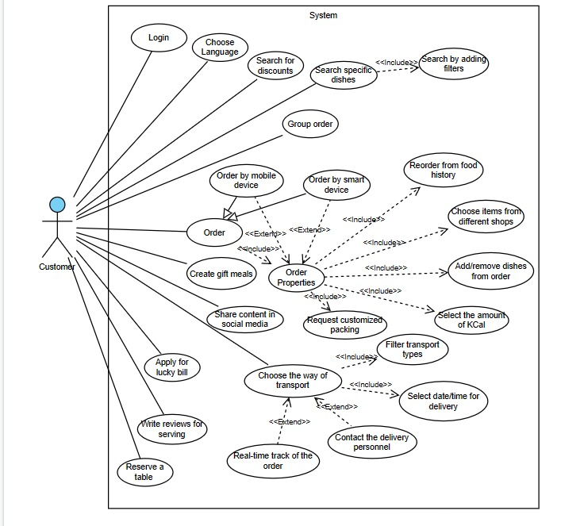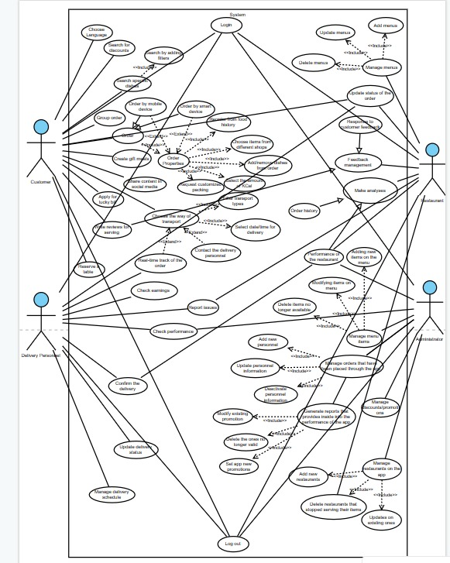

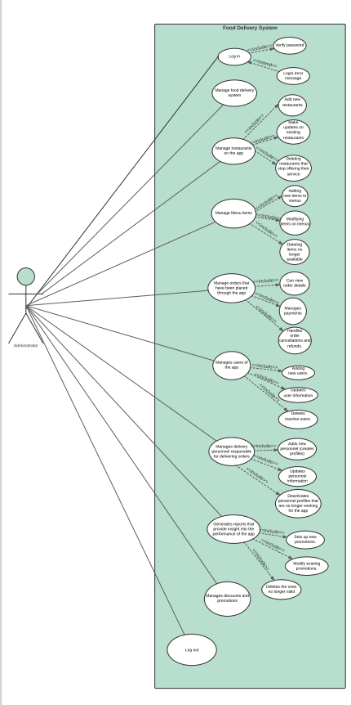

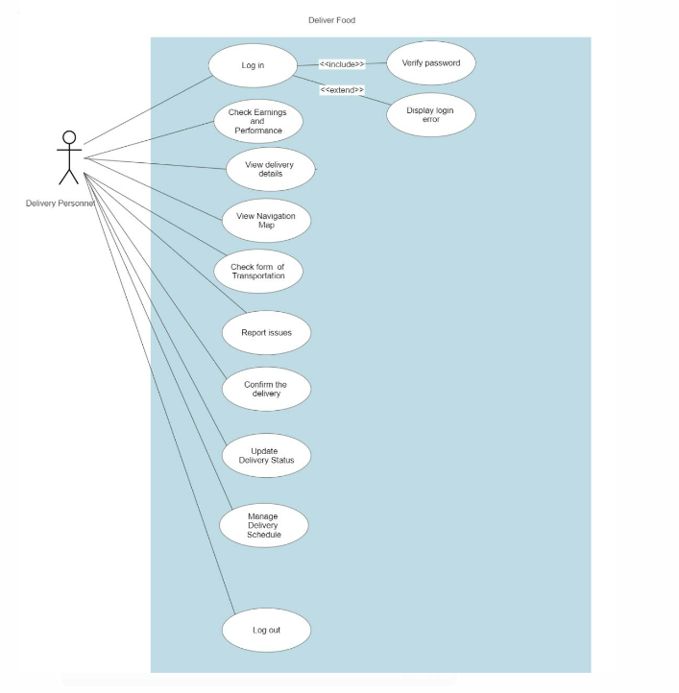

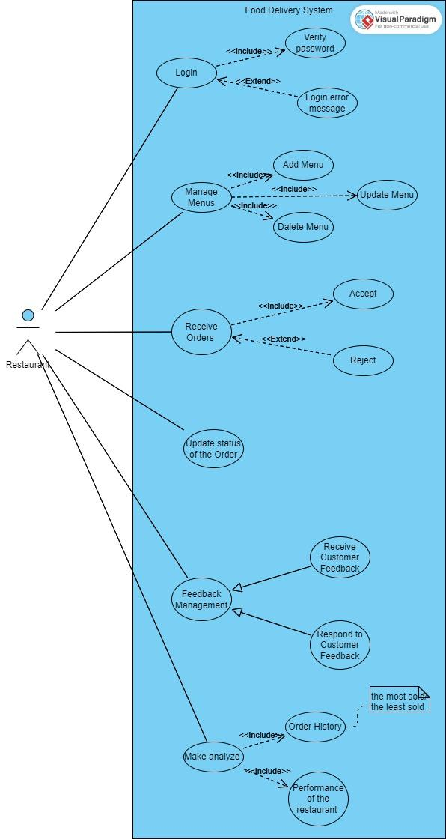

**State Diagrams**

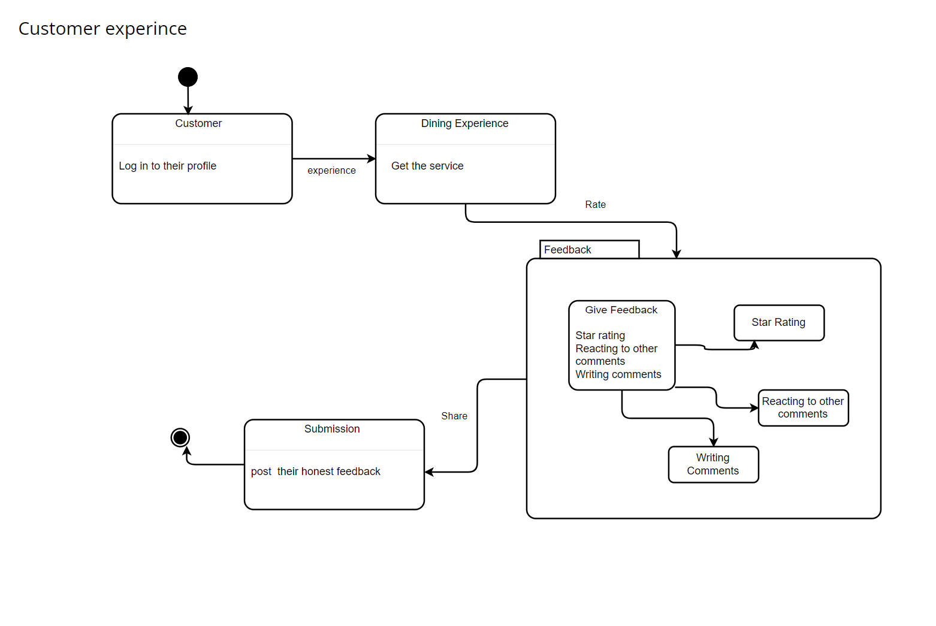

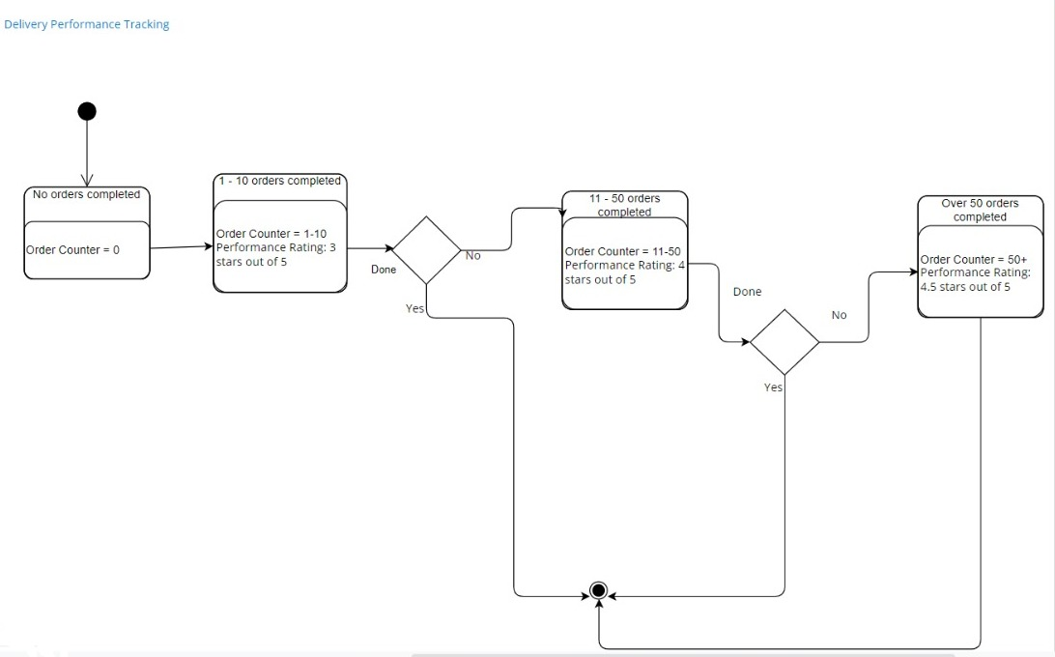

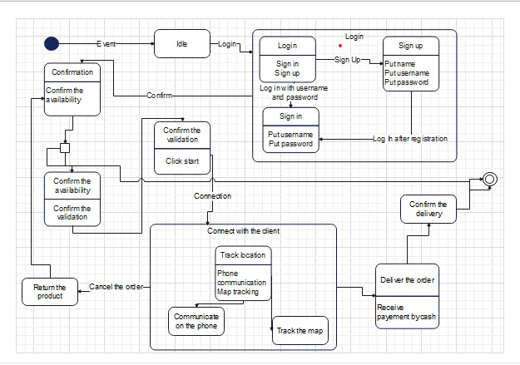

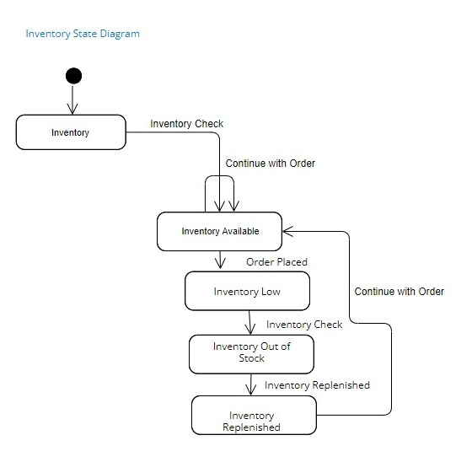

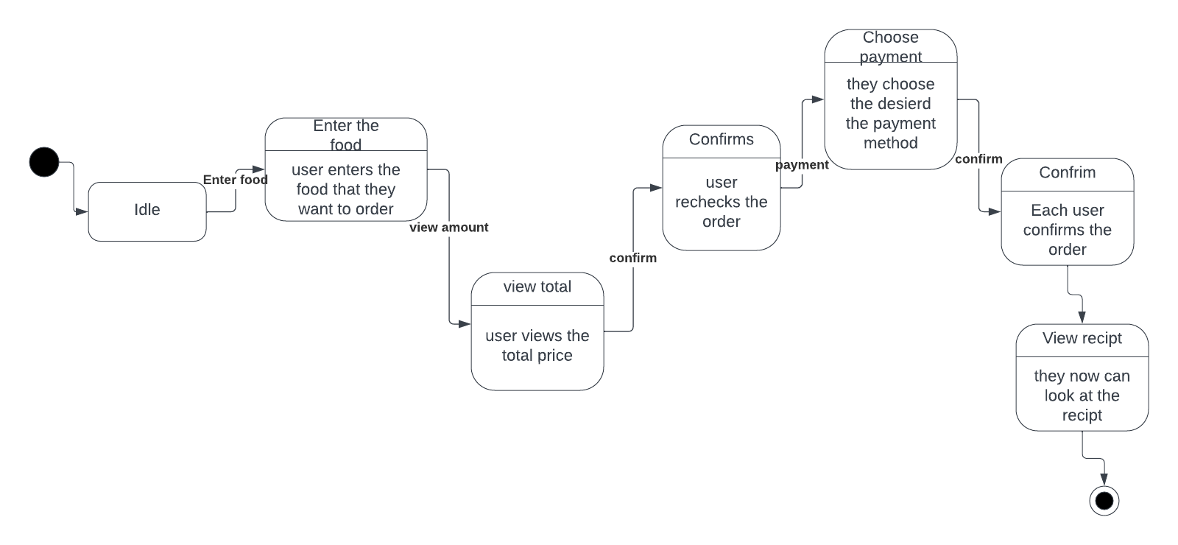

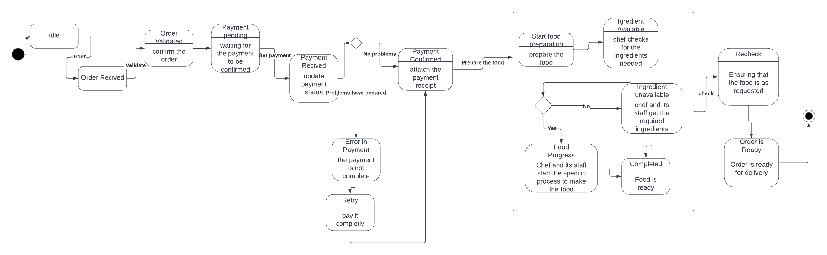

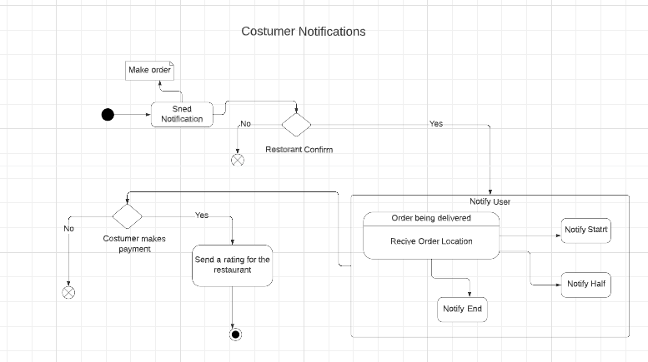

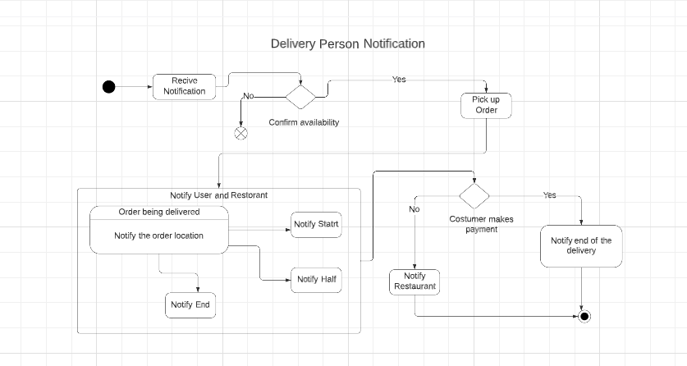

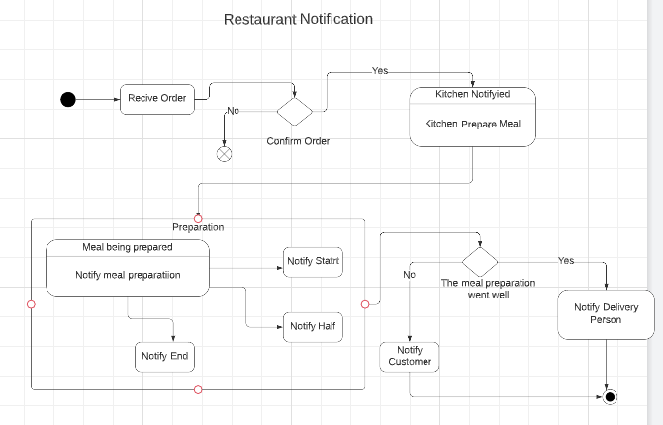

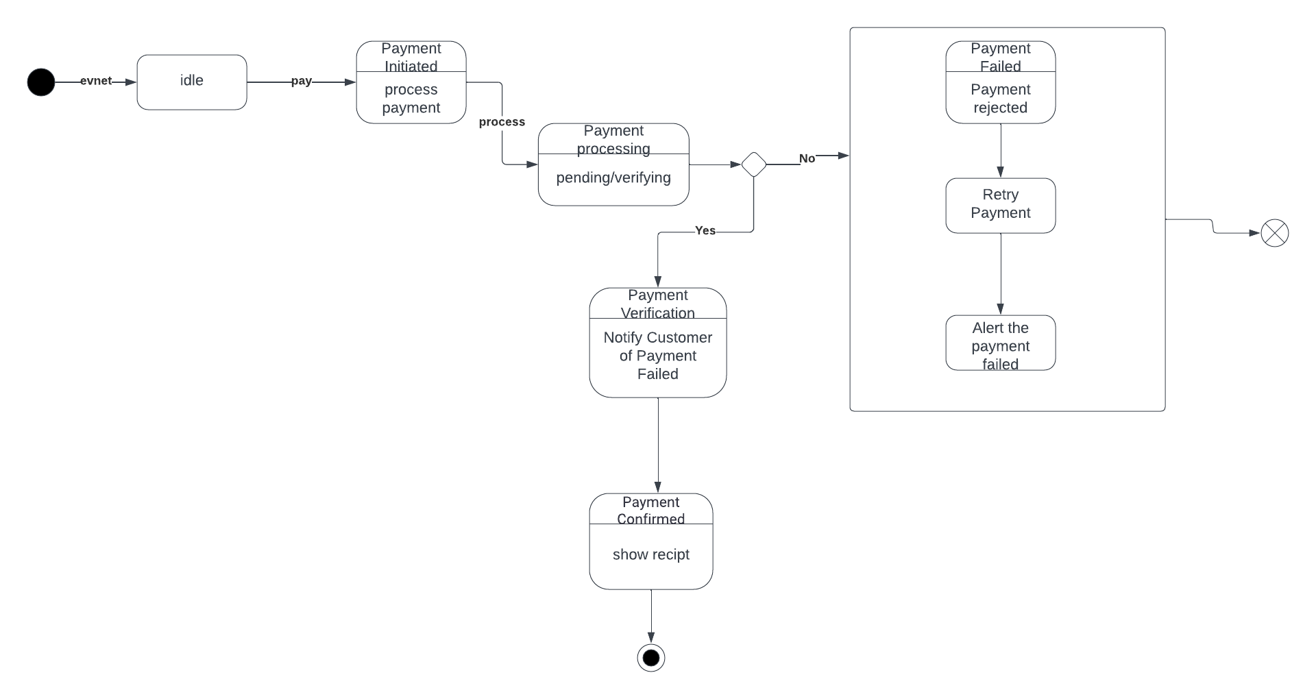

**Activity Diagrams**

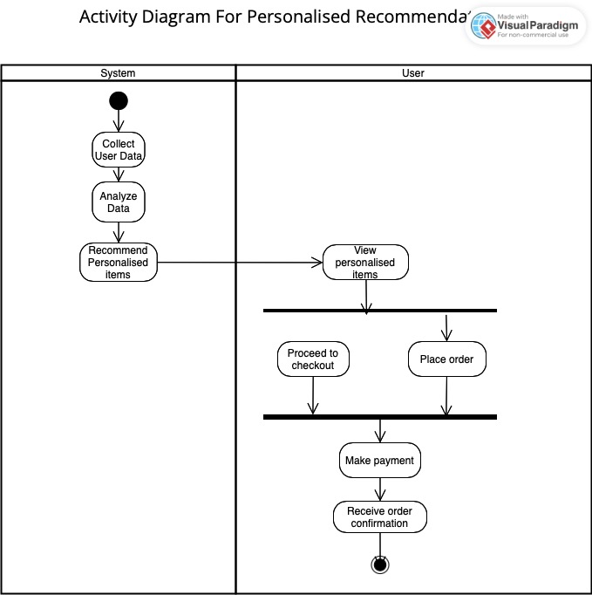

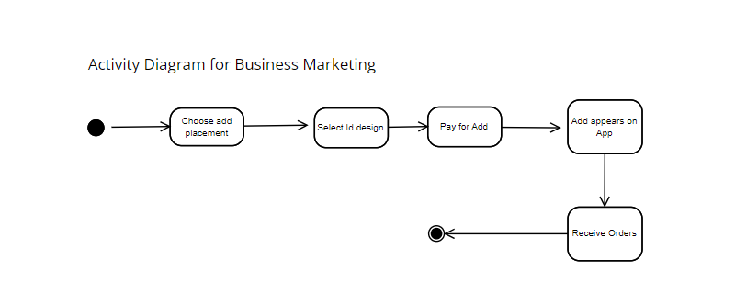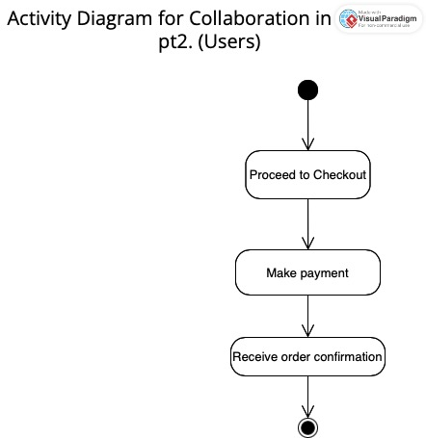

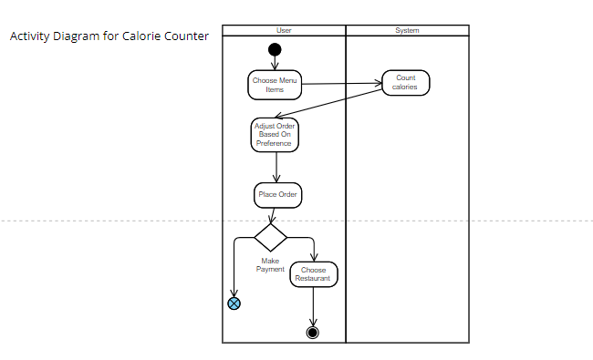

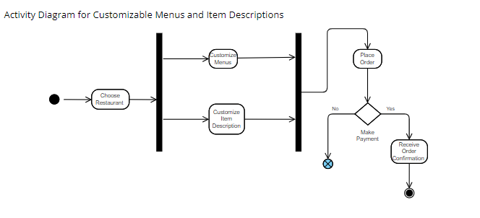

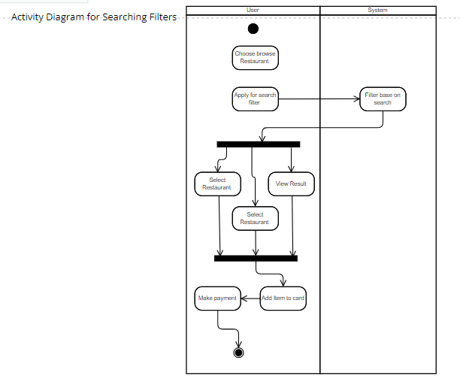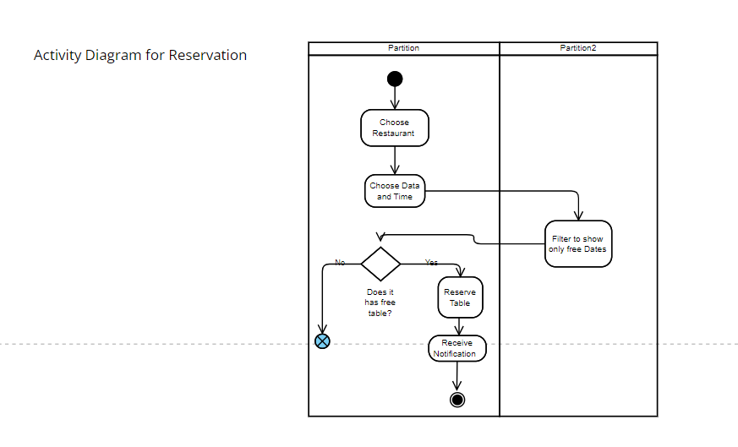

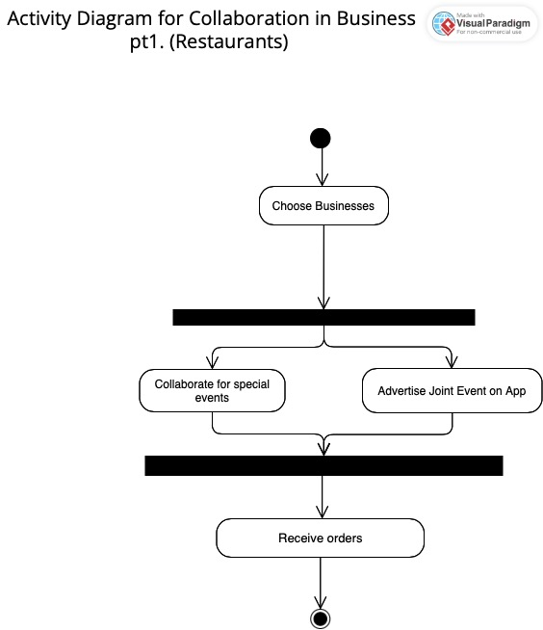

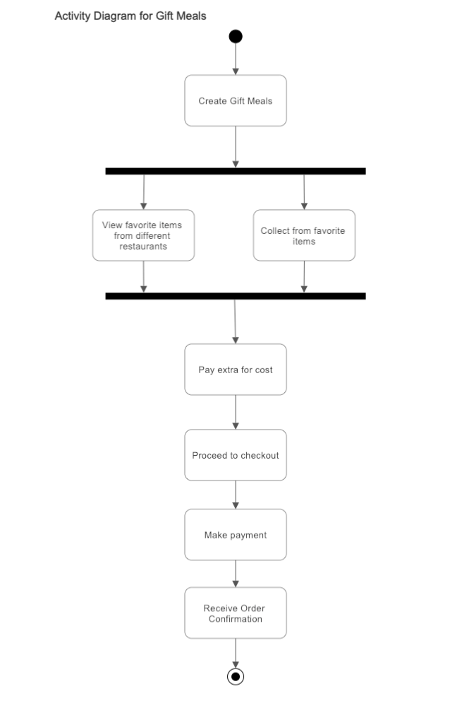

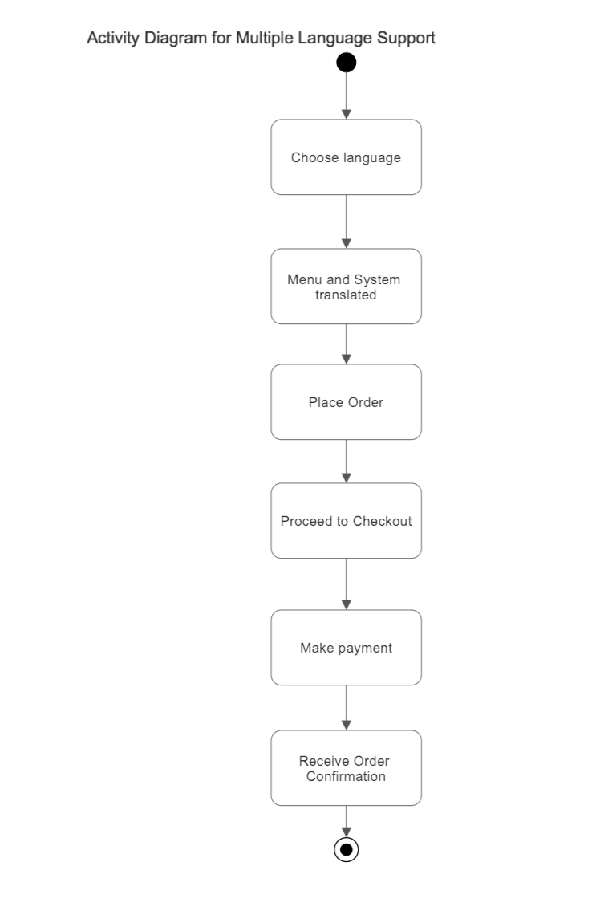

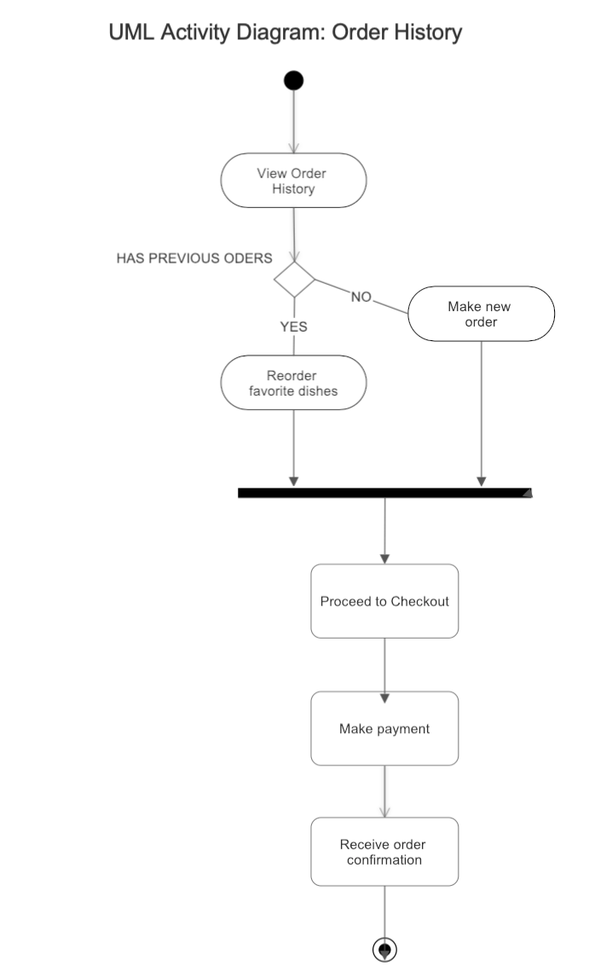

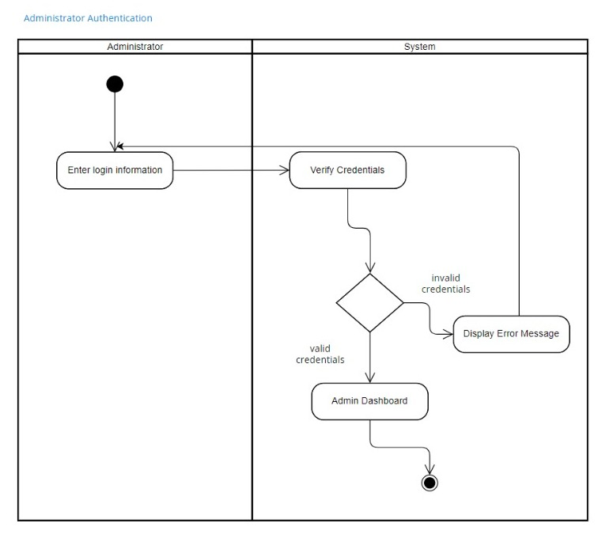

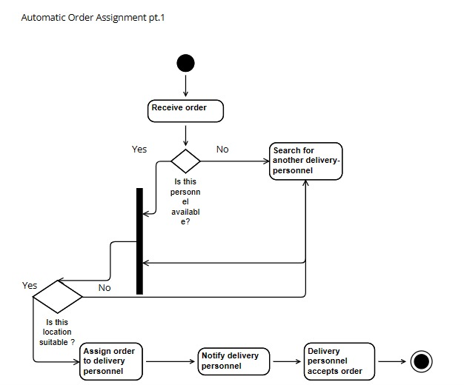

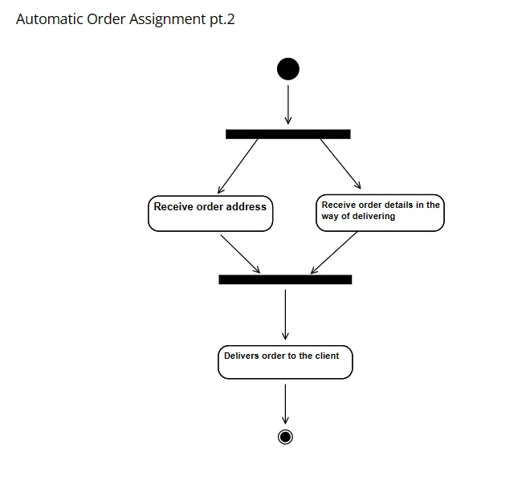

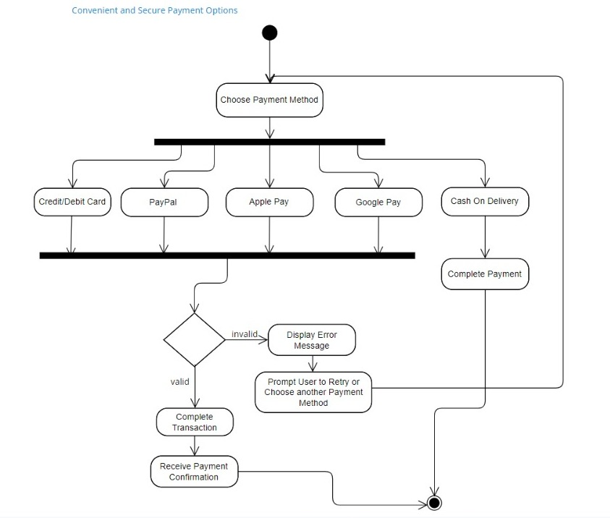

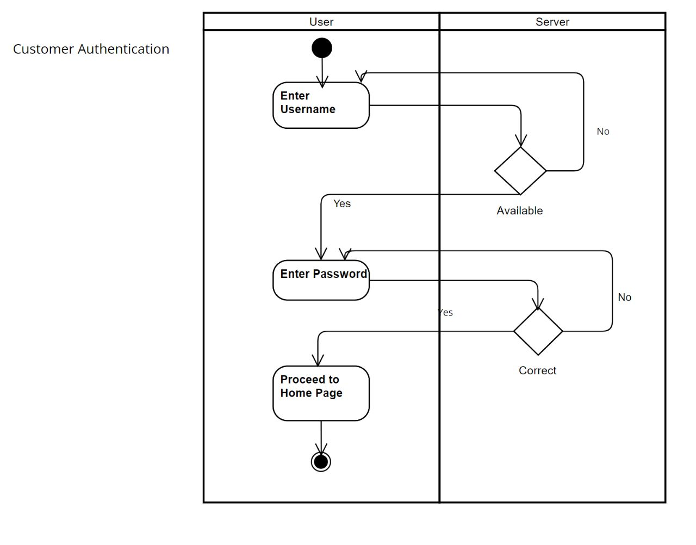

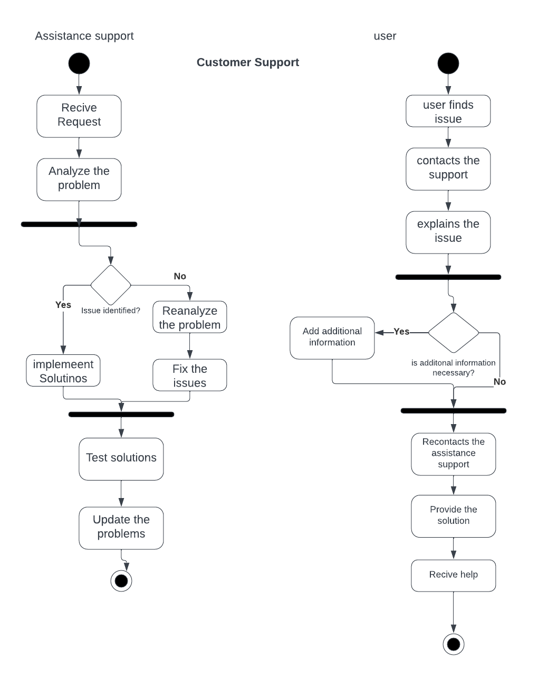

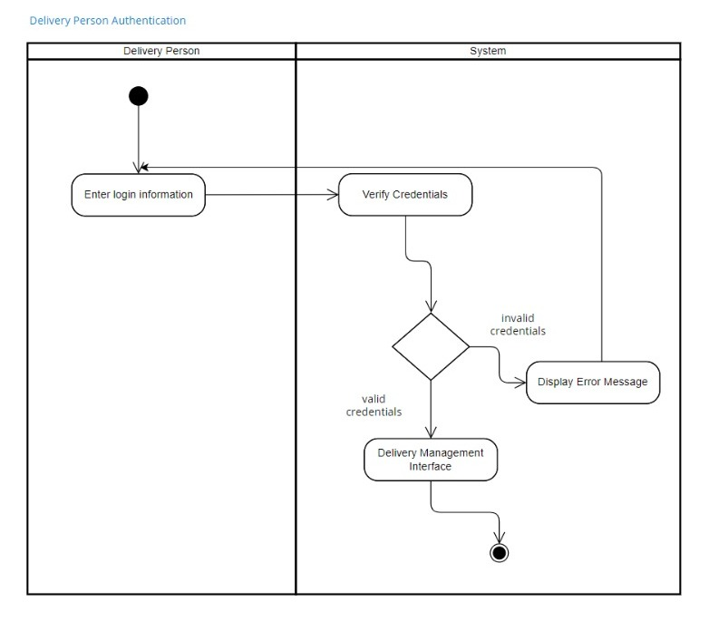

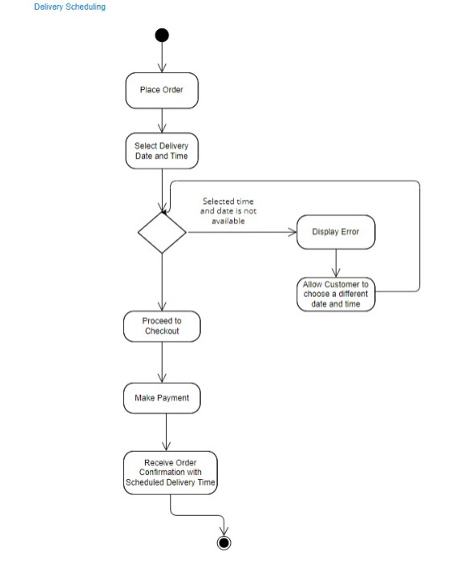

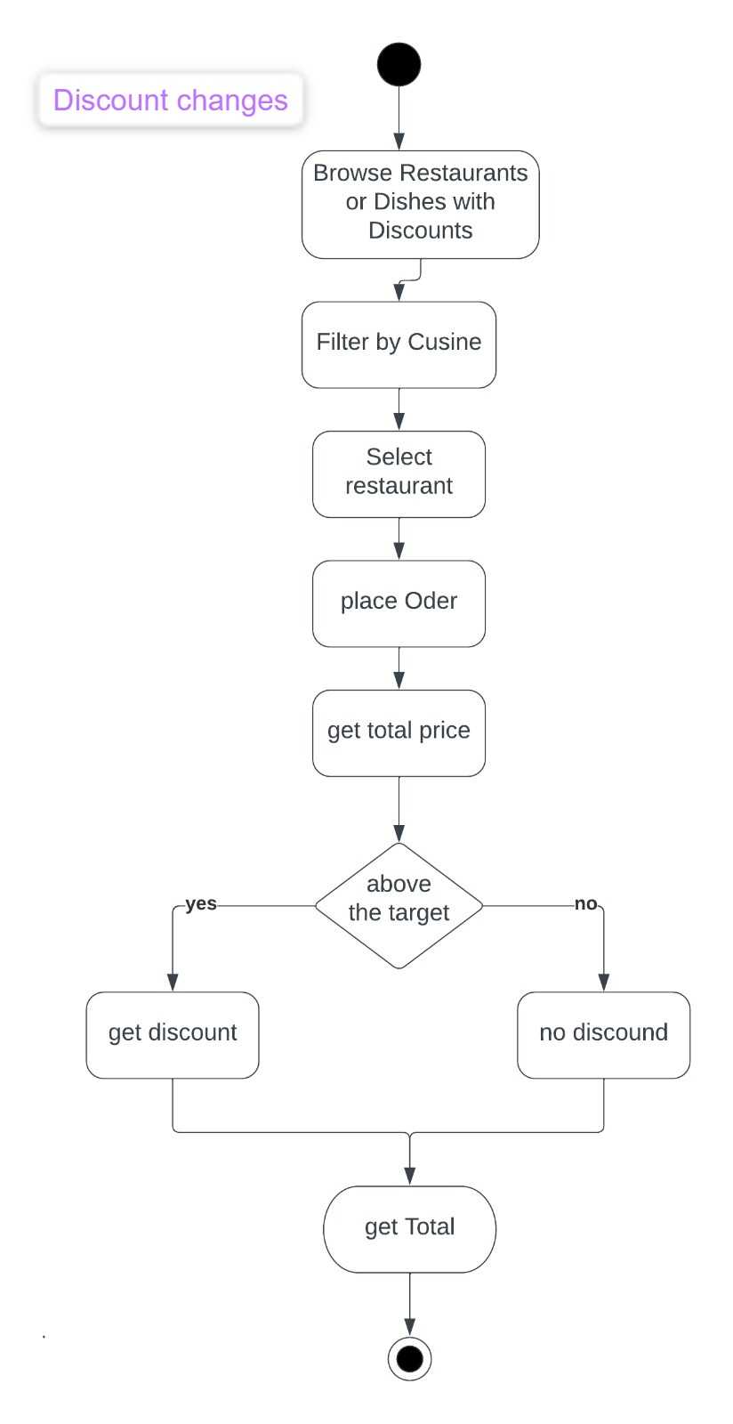

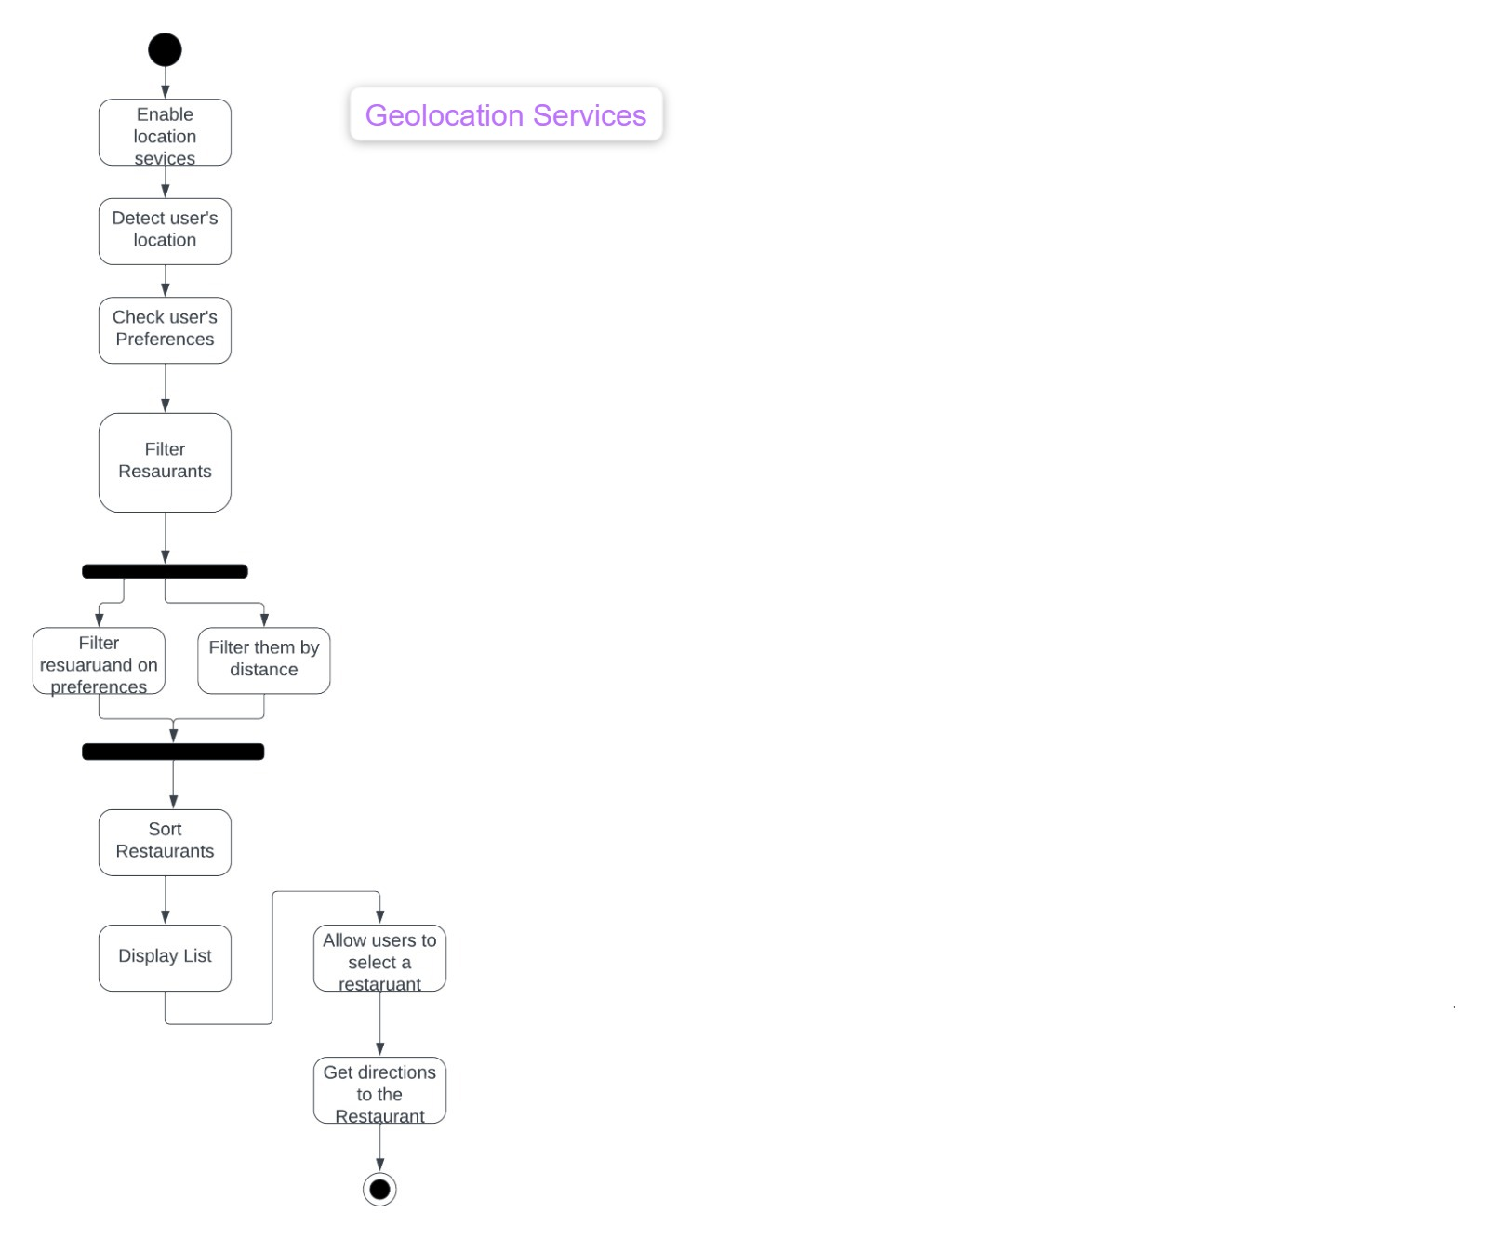

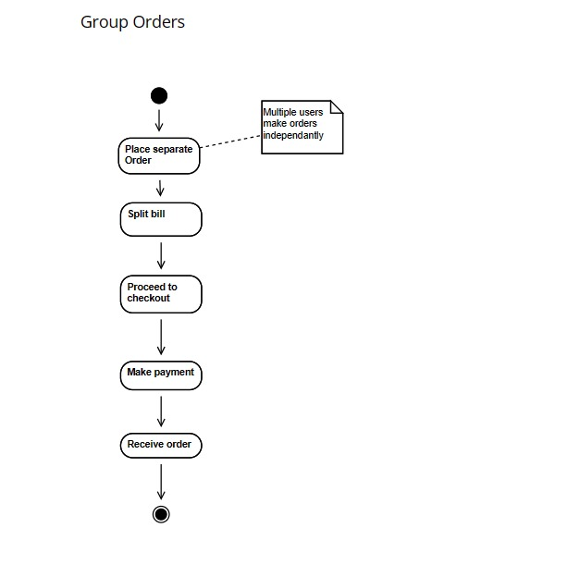

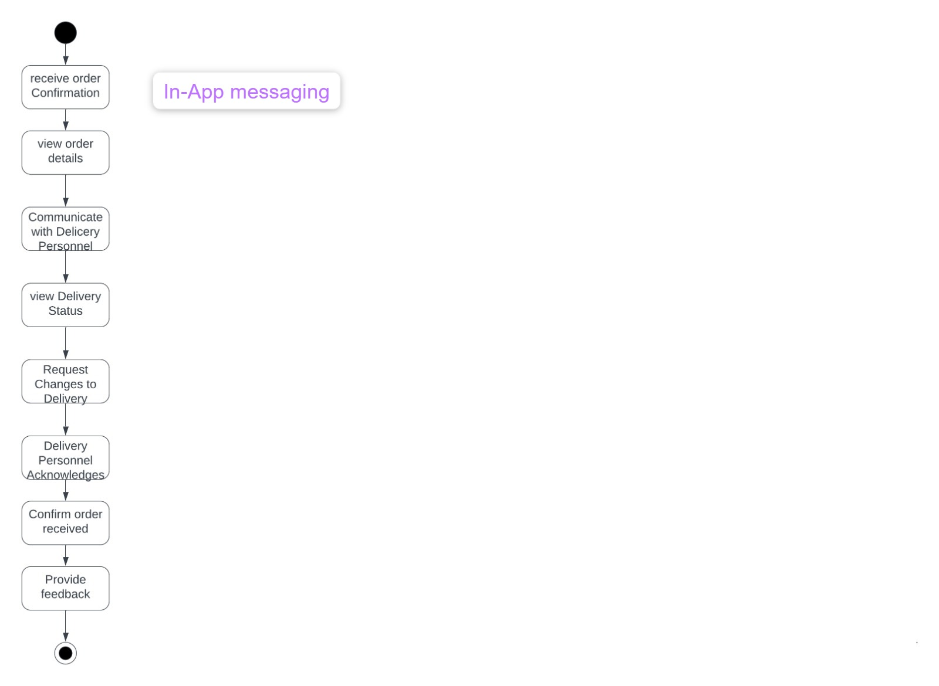

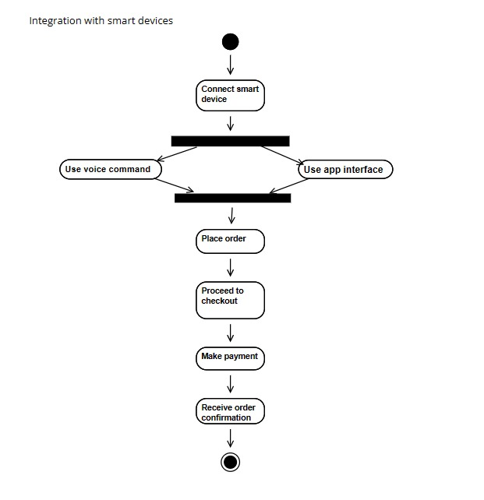

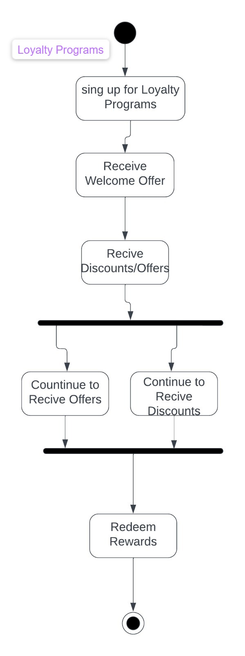

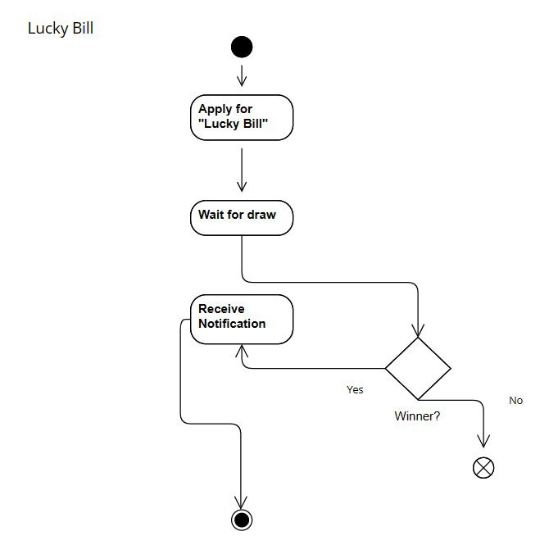

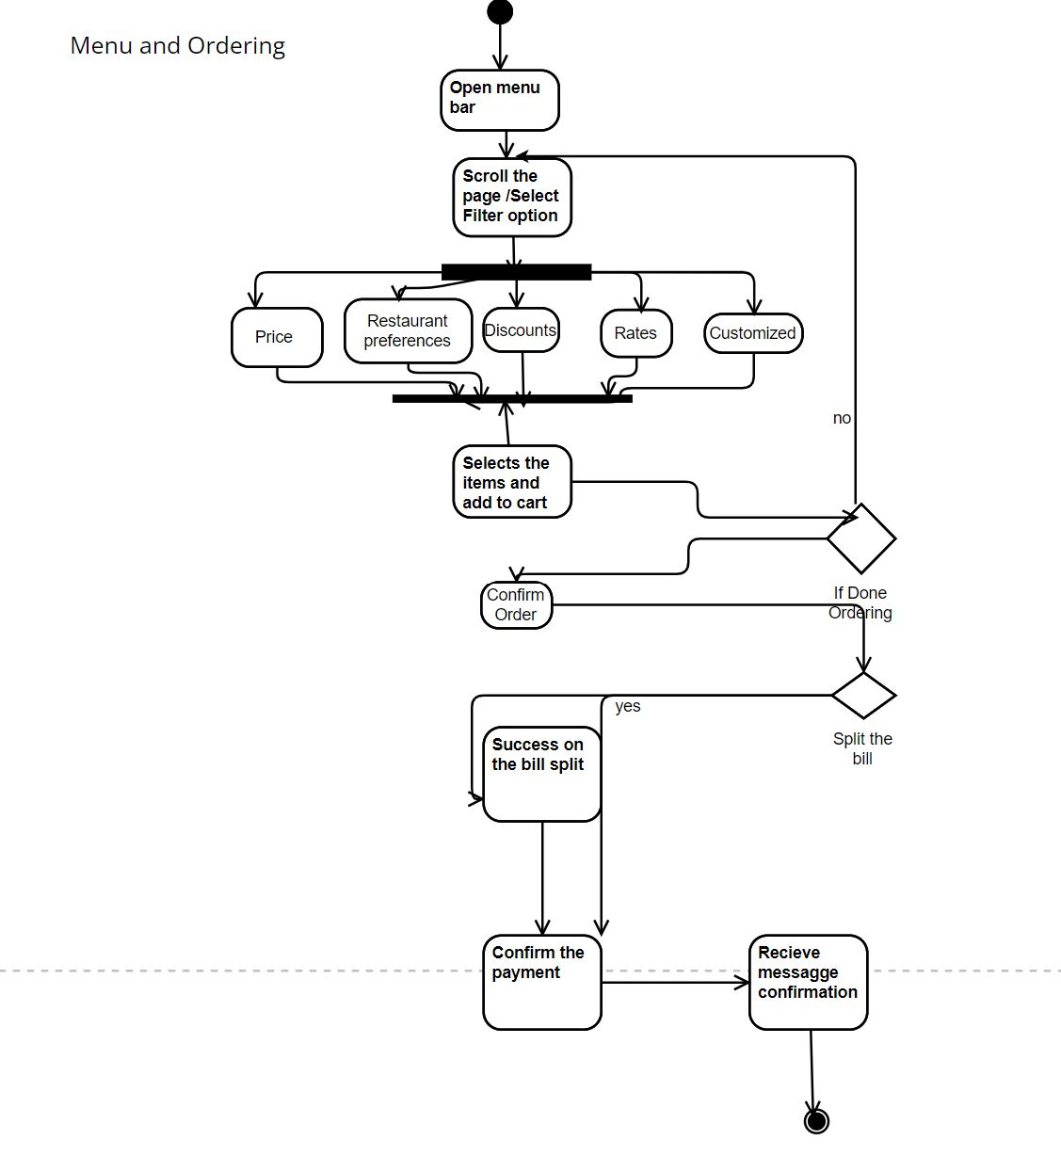

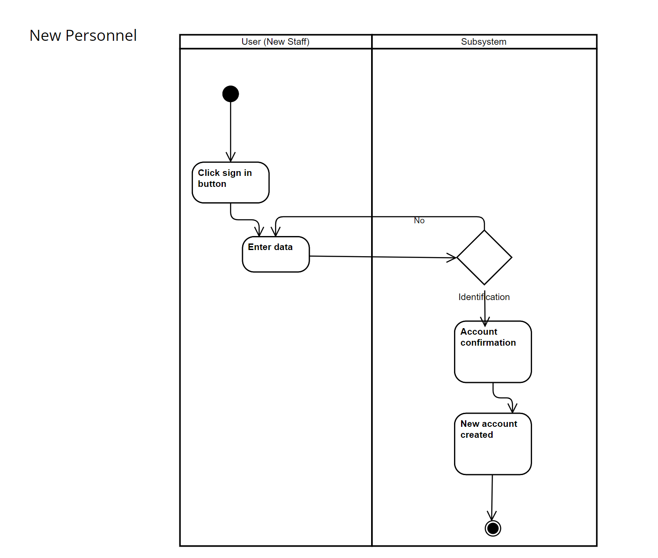

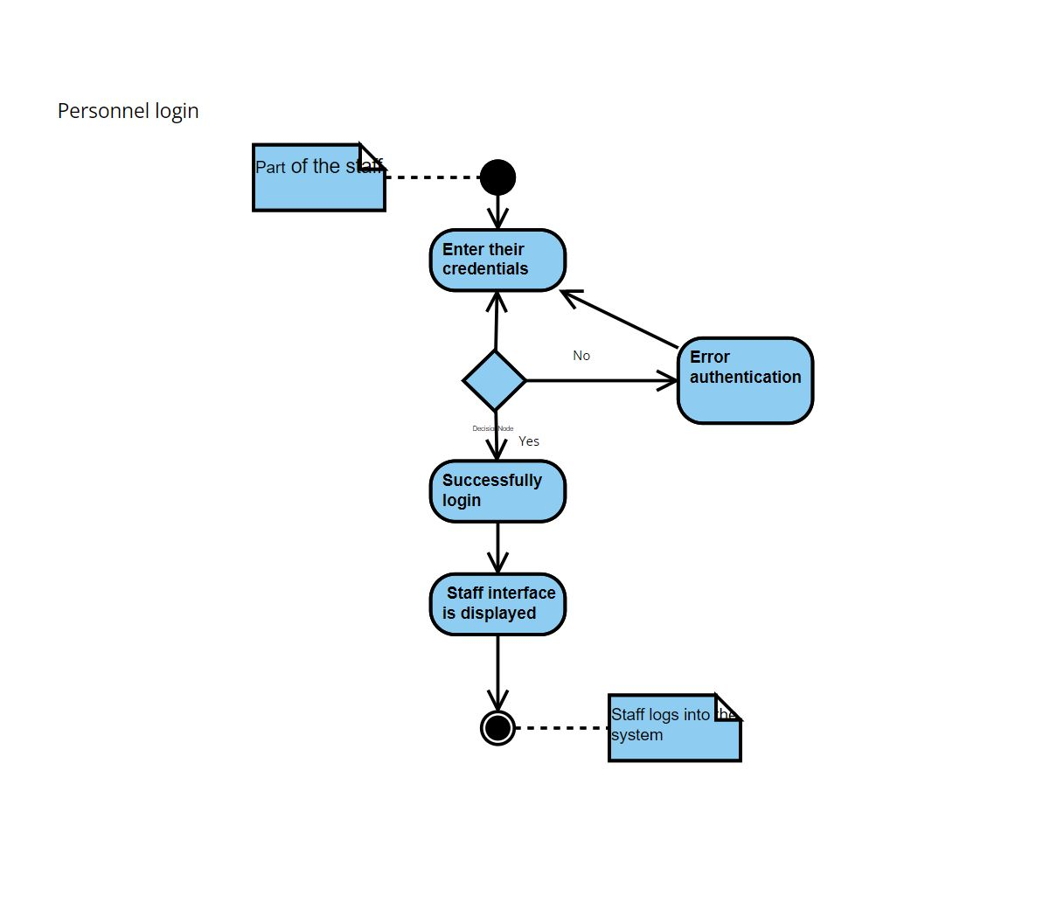

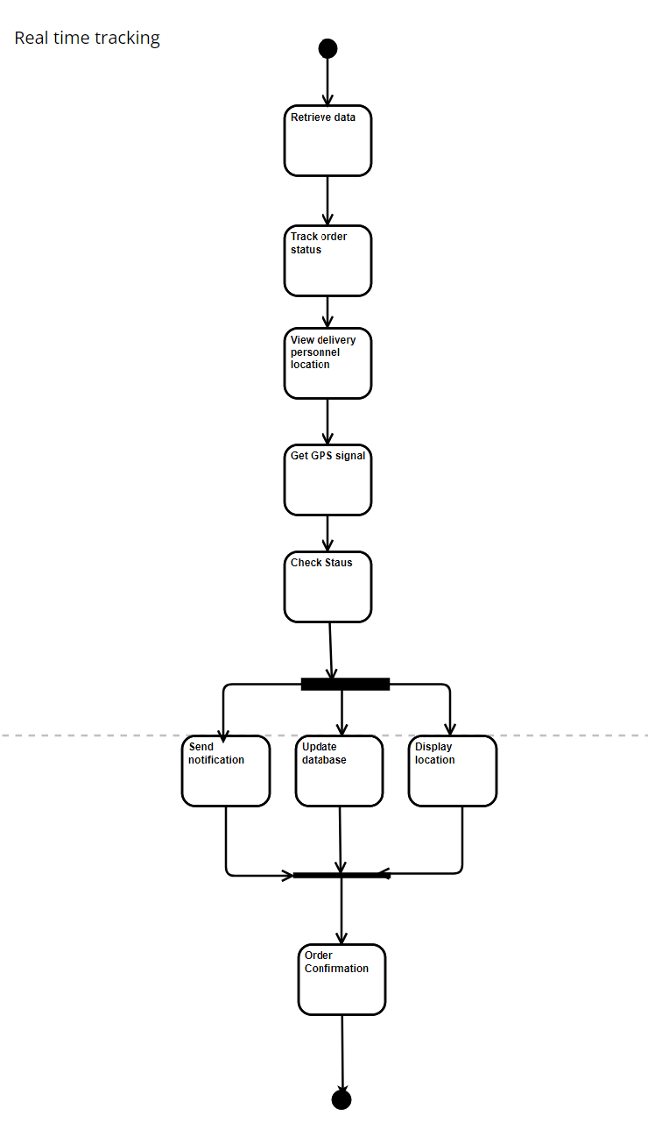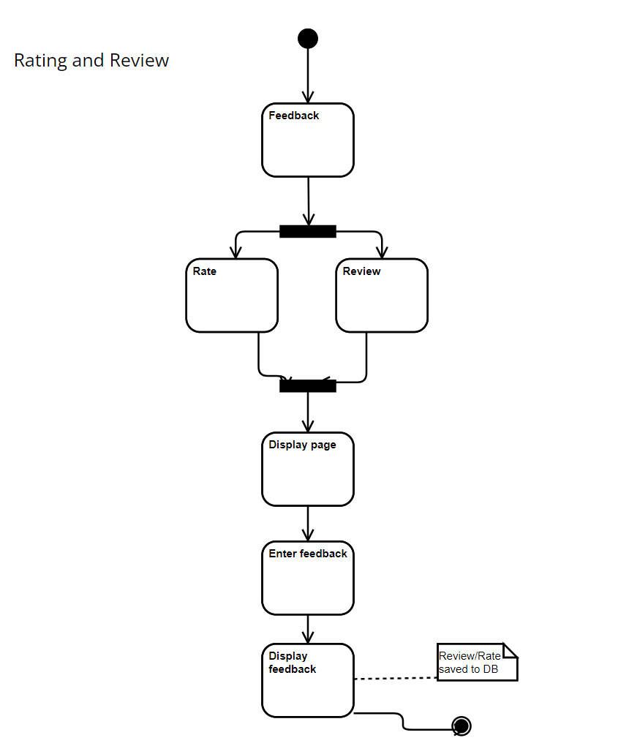

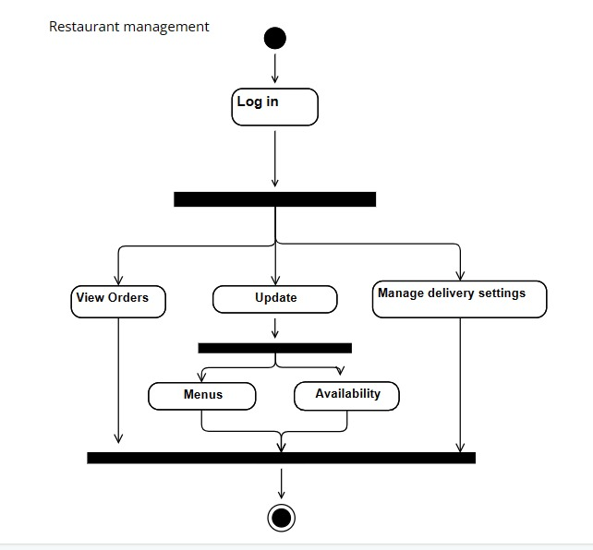

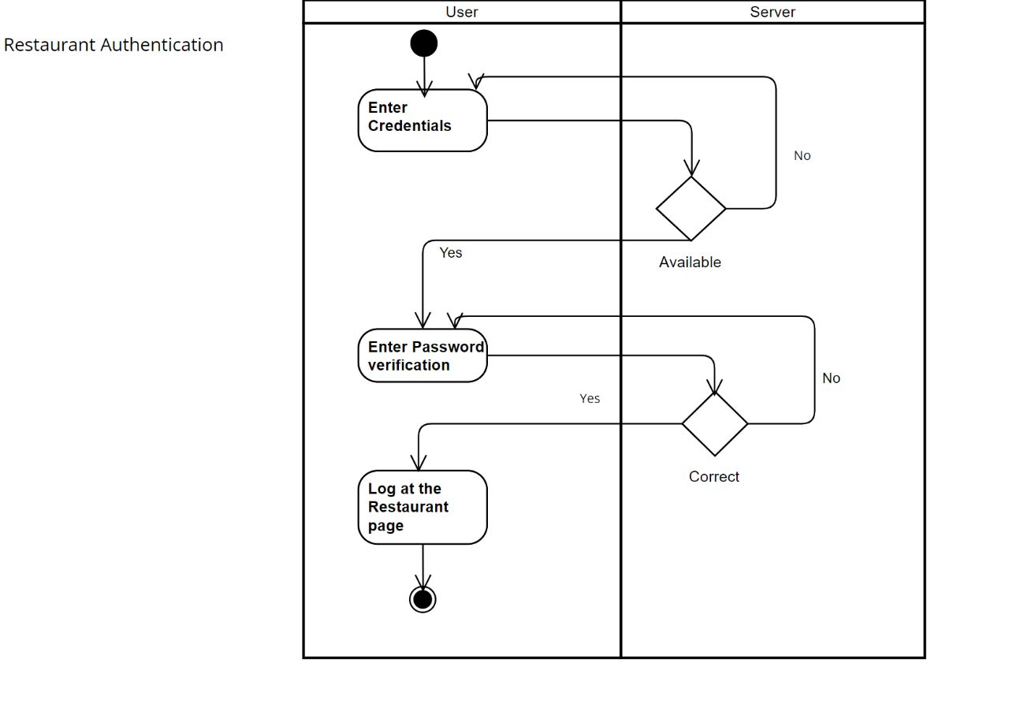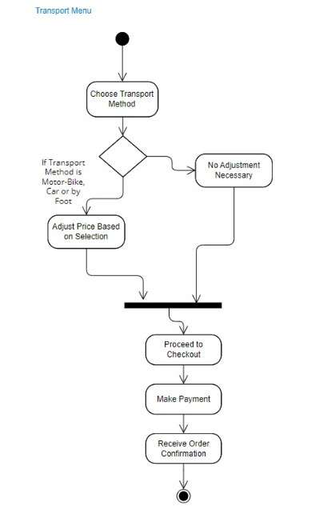

zzz